**Create a Continuous Delivery Pipeline in AWS with CodeCommit, CodeDeploy and CodePipeline**

1. Code commit repo for sourcecode and upload sample code/app.

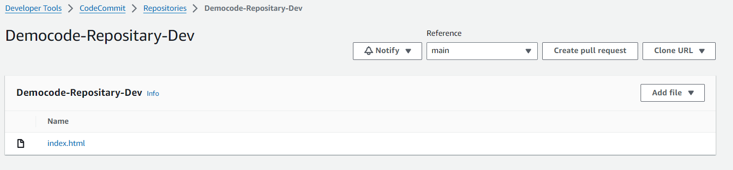

1. IAM for EC2 running on code-deploy – Ec2Roleforcodedeploy

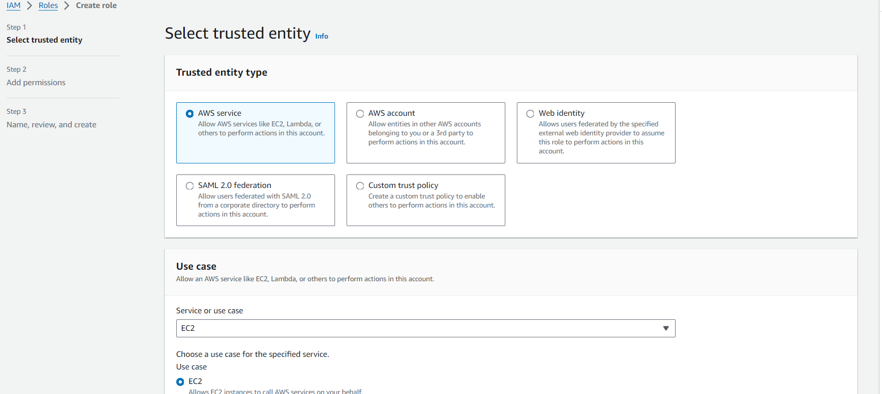

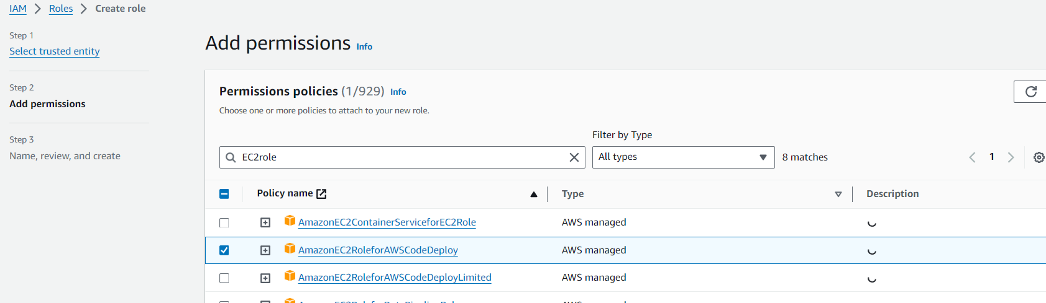

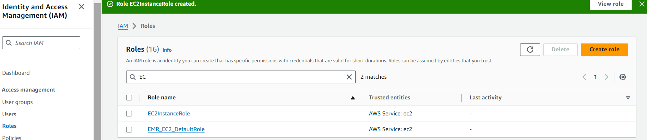

1. Create EC2 instance with user data to install cloud agent.

#!/bin/bash

yum -y update

yum install -y ruby

yum install -y aws-cli

cd /home/ec2-user

wget https://aws-codedeploy-us-east-2.s3.us-east-2.amazonaws.com/latest/install

chmod +x ./install

./install auto

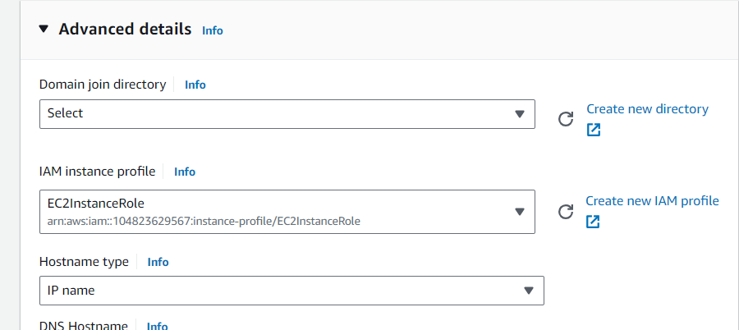

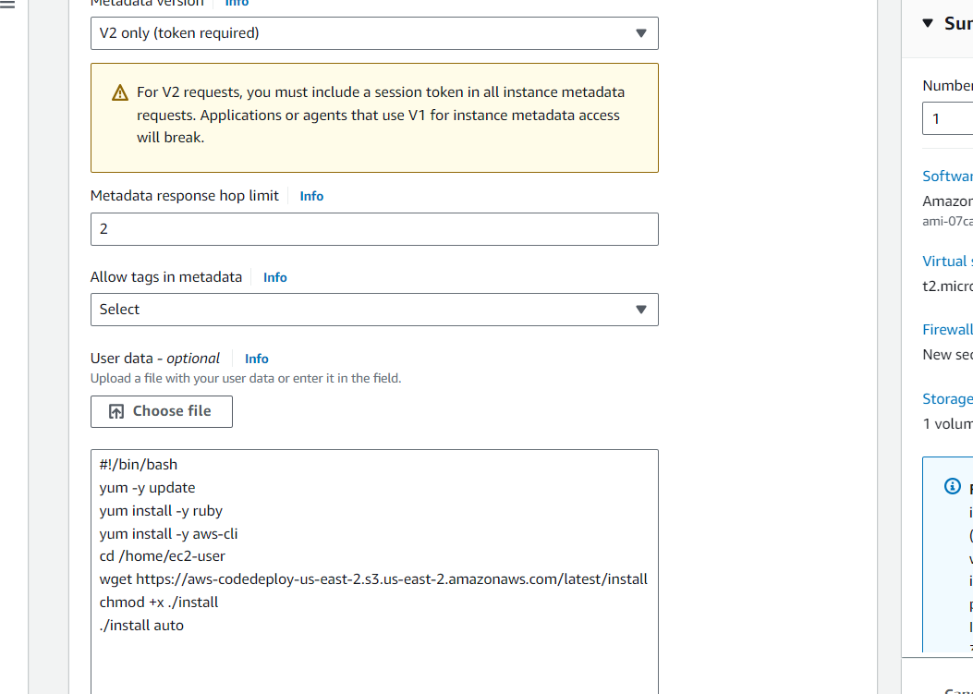

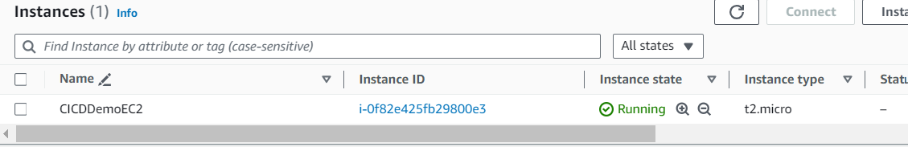

1. Role for code-deploy

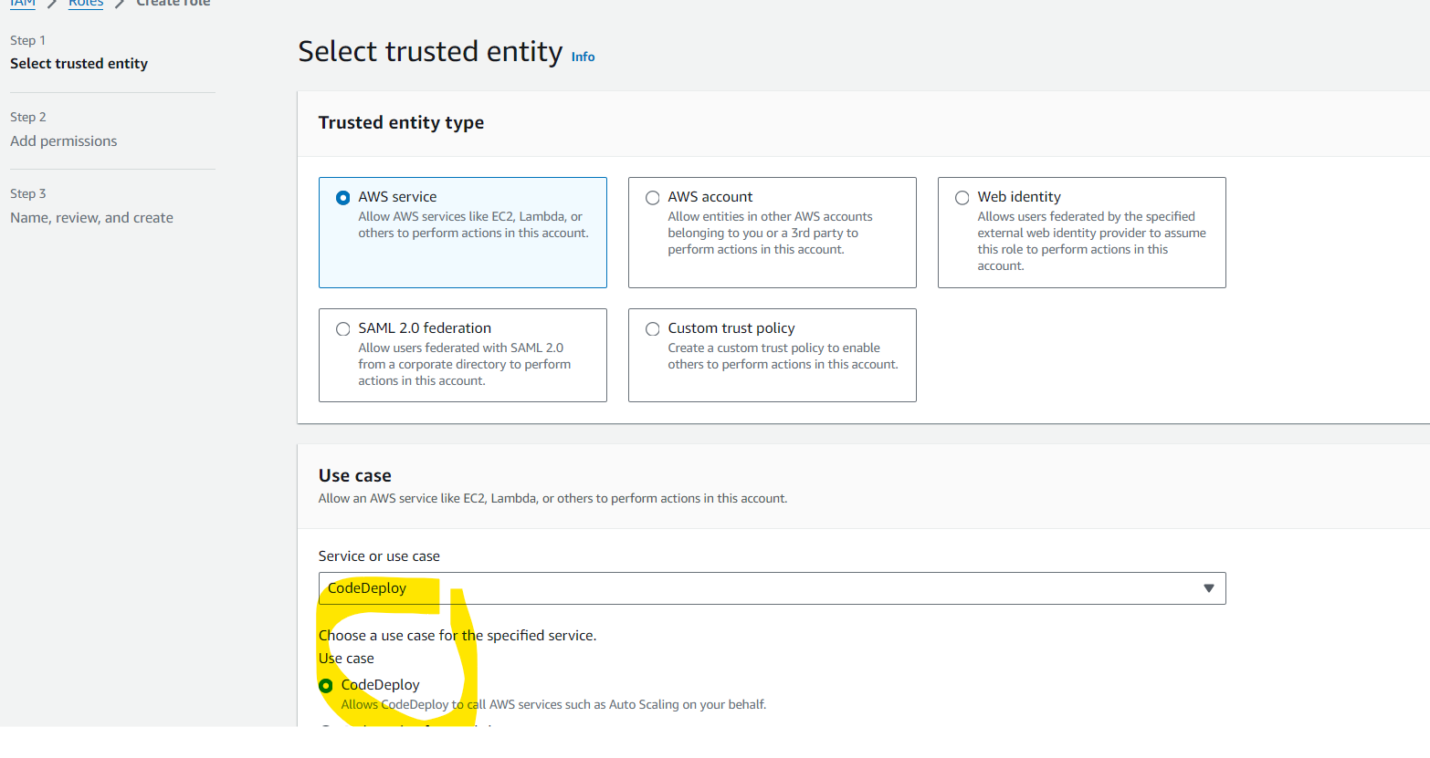

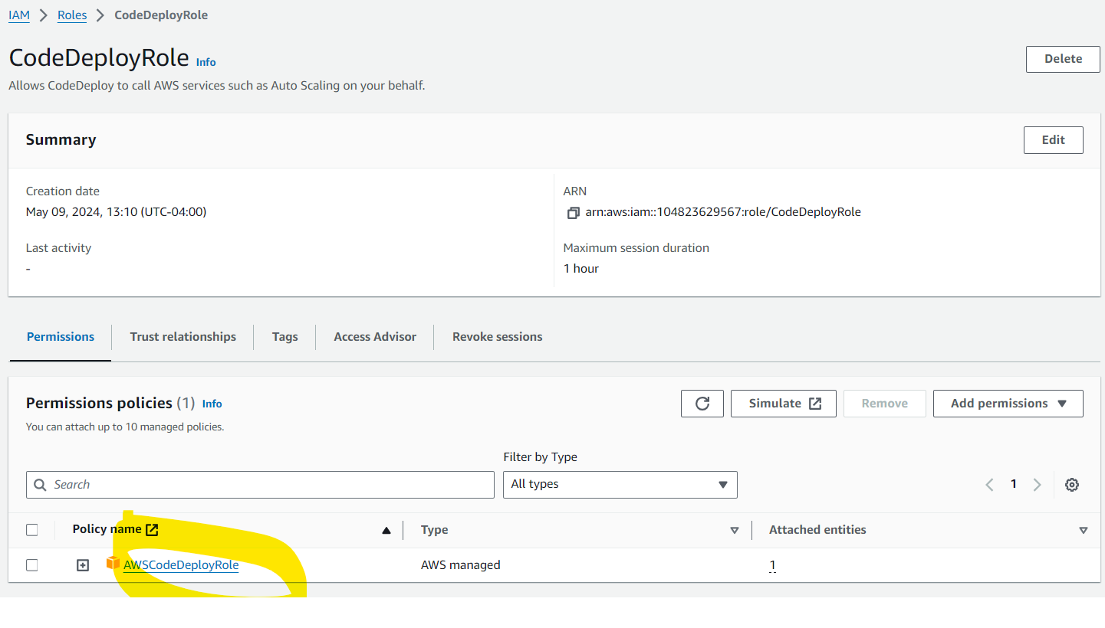

1. Create application in Code-Deploy

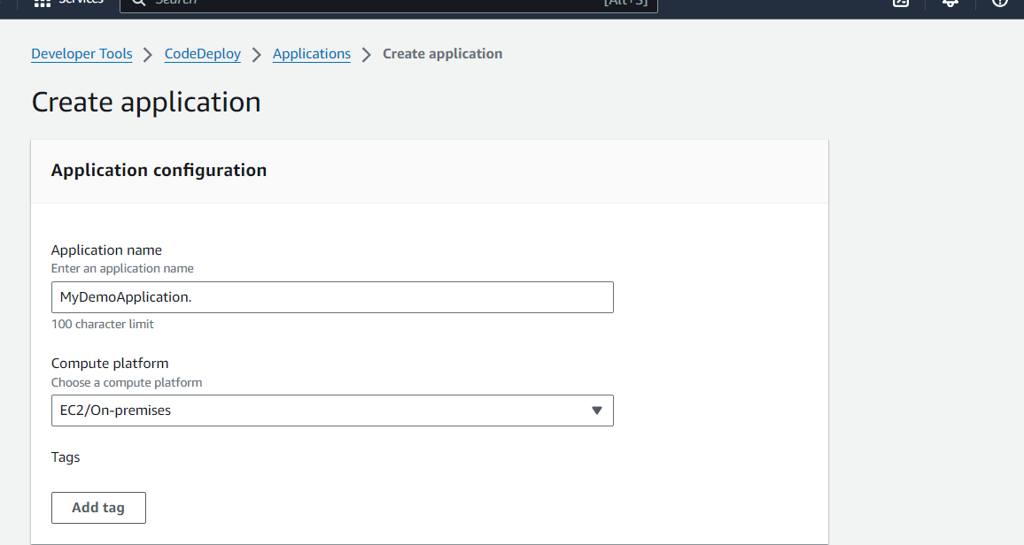

Create deployment group: MyDemoDeploymentGroup

* Deployment Setting of OneAtATime
* Deployment Type of In-Place
* Load Balancer: Disabled (Not required)

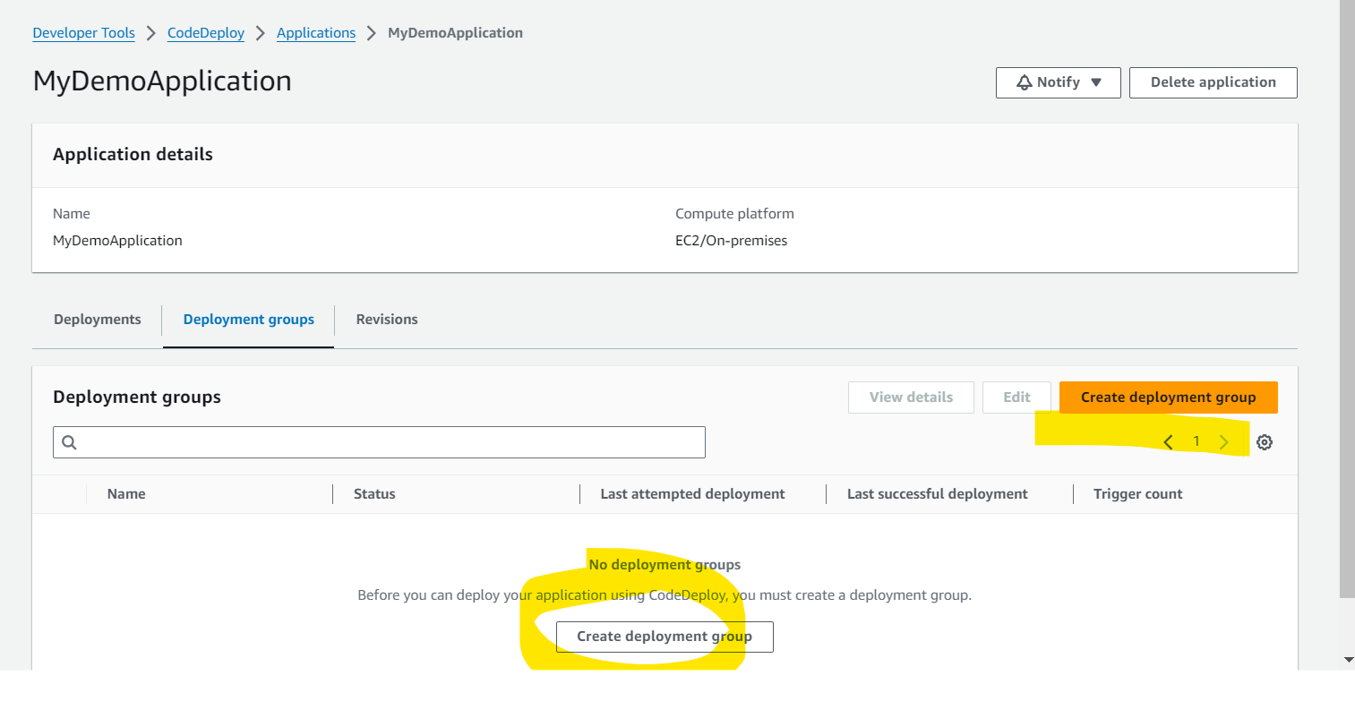

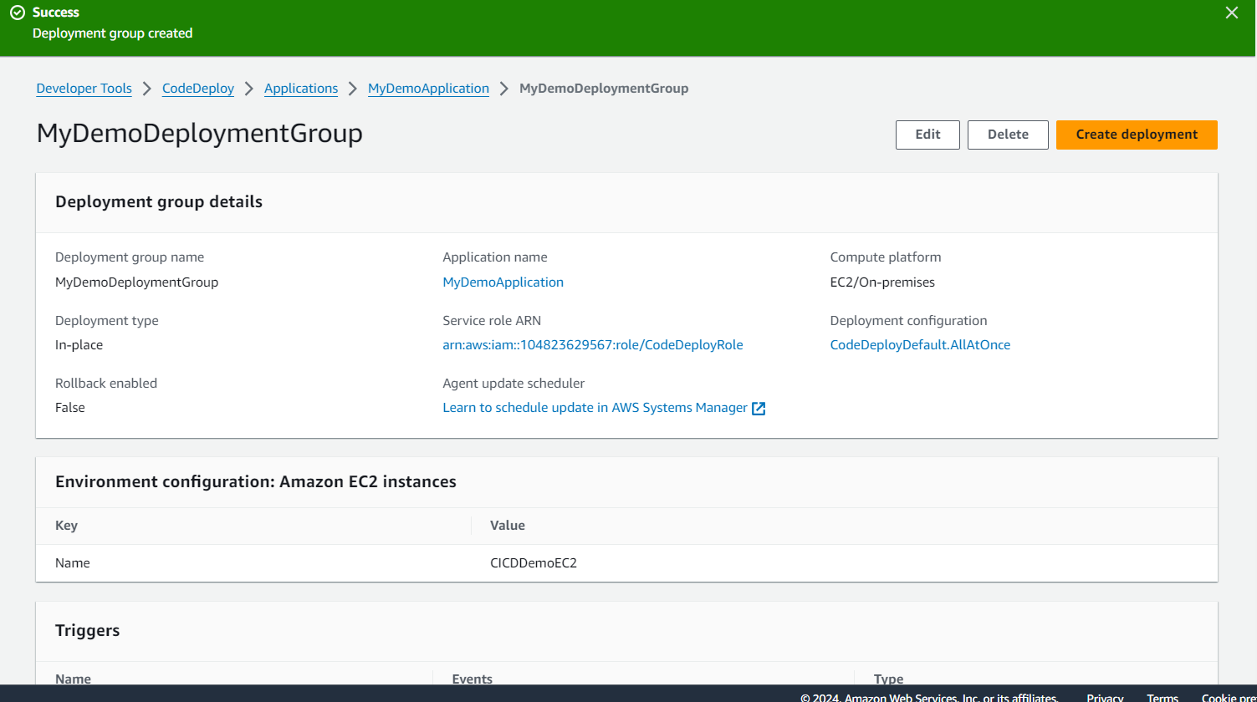

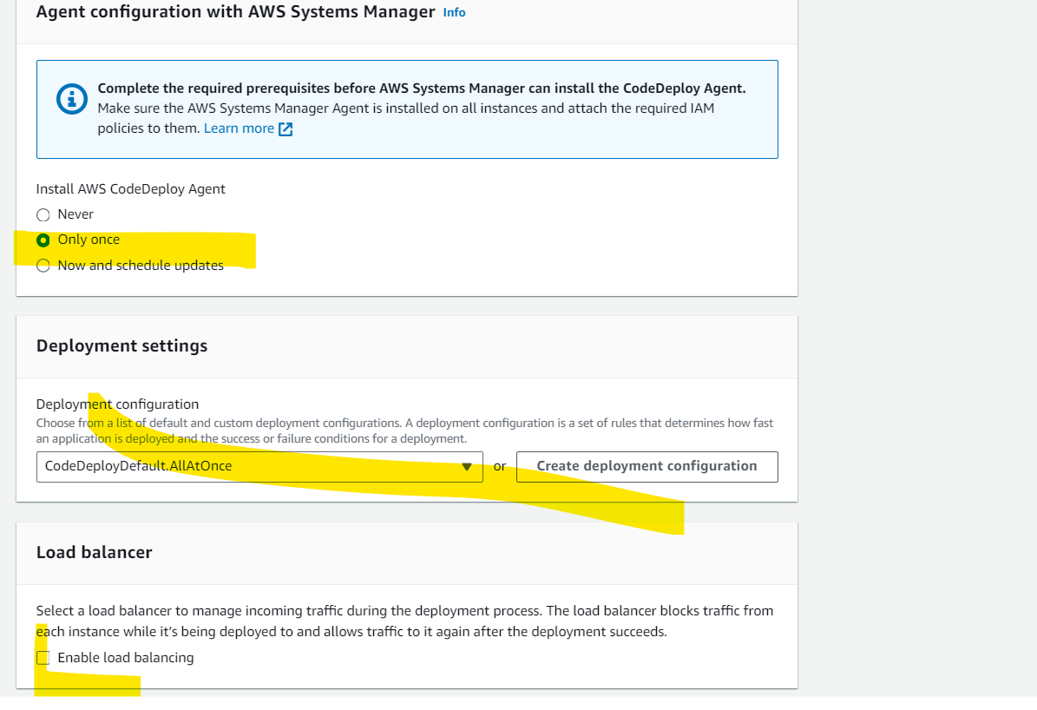

In CodeRepo create the appspec file for code-deploy.

1. Create a file named install_httpd.sh in your existing CodeCommit repository. This file contains the command to install the coupon system. Following is the content of the install_httpd.sh file. In order to do that, go to your Code Commit repository and click on Add FIle and select Create file #!/bin/bash
2. yum install -y httpd
3. systemctl start httpd

install_httpd.sh

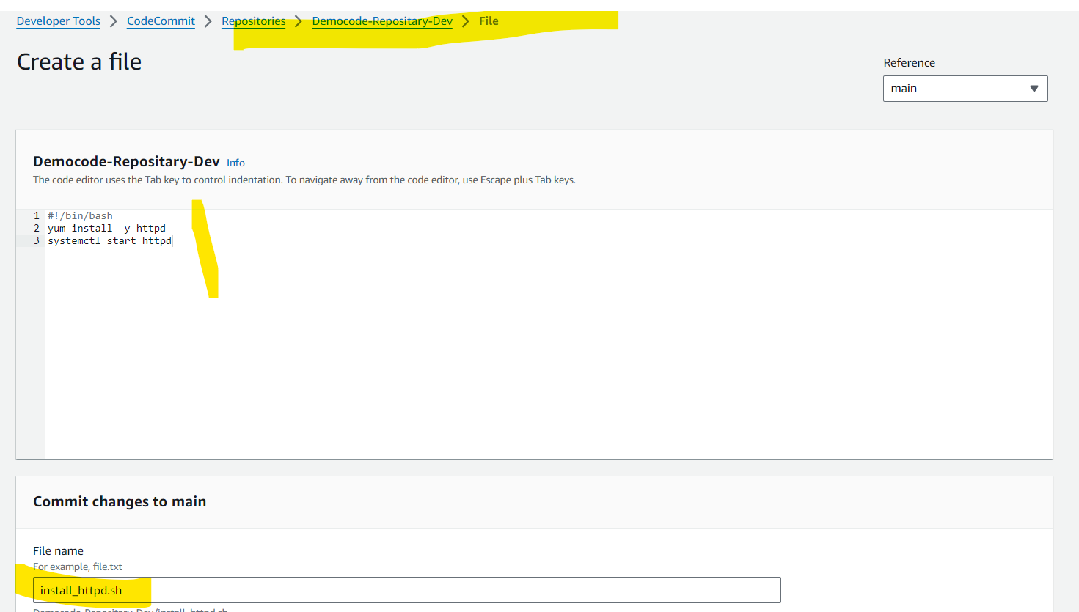

Appspec.yaml

version: 0.0

os: linux

files:

- source: /index.html

destination: /var/www/html

hooks:

BeforeInstall:

- location: install_httpd.sh

runas: root

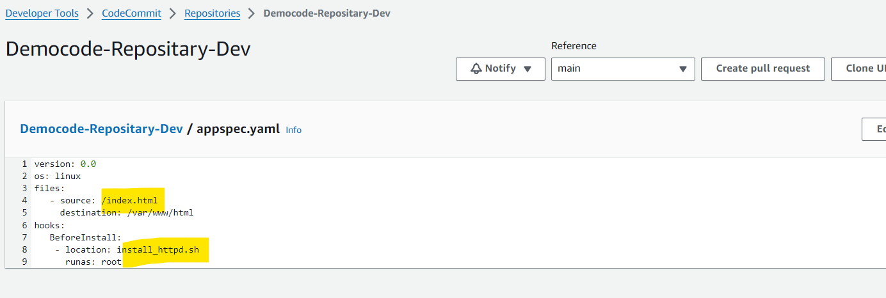

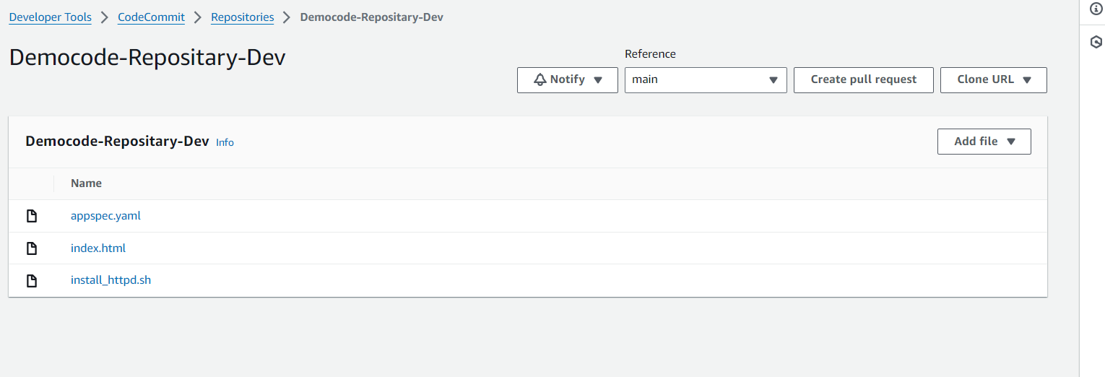

**create pipeline**

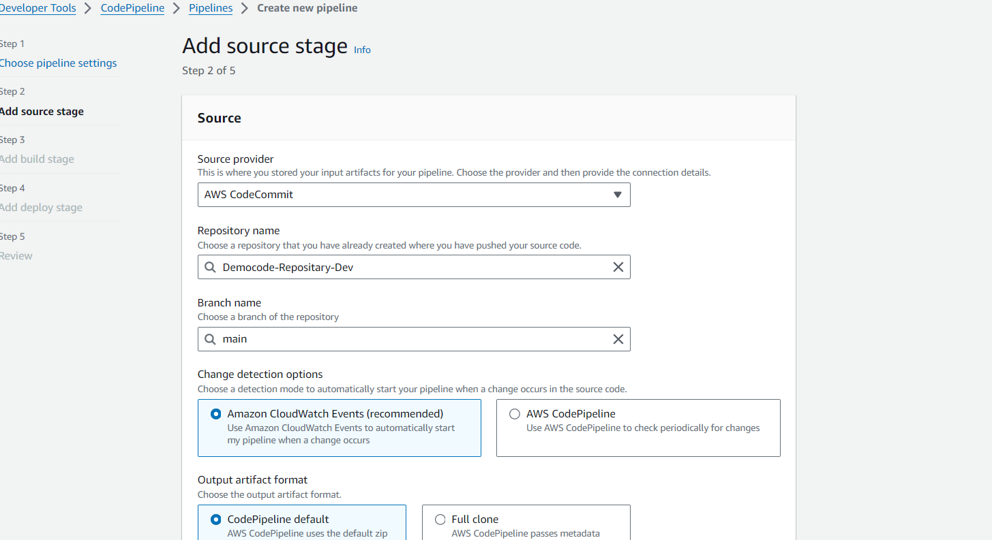

**Skip Buil**

**Add Deploy information**

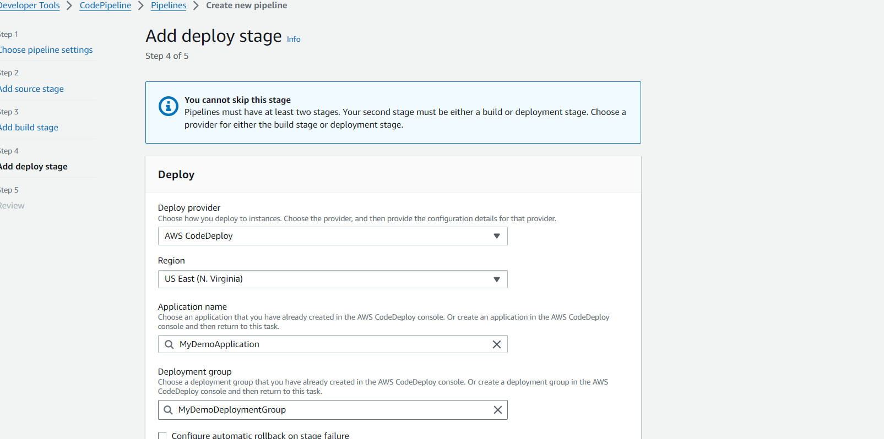

**Execution Details**

